Training Notes: Your First Java Program
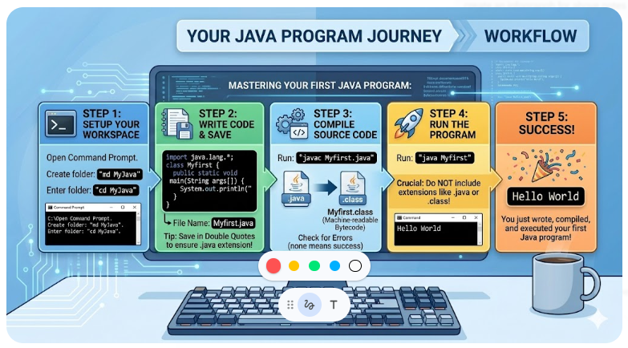
1. Setting Up the Workspace
Before writing any code, it is best practice to keep your Java files organized in a dedicated folder.
- Open the Command Prompt.
- Create a new directory: Type md MyJava (md stands for "make directory") and press Enter.
- Navigate into the directory: Type cd MyJava (cd stands for "change directory") and press Enter.
- Verify the folder: Type dir to see the contents. It should currently be empty.
2. Writing the Code
For this foundational lesson, use a simple text editor like Notepad rather than a complex IDE. This helps you understand the raw mechanics of Java programming.

Open Notepad and type the following Java skeleton code:
Java
import java.lang.*;

class Myfirst {
public static void main(String arg[]) {
System.out.println("Hello World");
}
}
Code Breakdown (Briefly):
- import java.lang.*;: Imports standard Java classes (optional for basic programs, but good practice as shown in the video).
- class Myfirst: Declares the class. Note: The class name must match the file name you will save later.
- public static void main(String arg[]): The main method where the program execution begins.
- System.out.println("Hello World");: The command used to print text to the screen (unlike printf in C or cout in C++).
3. Saving the File
Properly saving the file is critical when using standard text editors to avoid file extension issues.
- In Notepad, go to File > Save (or press Ctrl + S).
- Navigate to your newly created folder: C:\MyJava.
- File Name: Save the file exactly as "Myfirst.java" (including the double quotes).
- Why use double quotes? Wrapping the name in quotes forces Notepad to save it with a .java extension. Without quotes, Notepad might accidentally save it as Myfirst.java.txt, which the compiler will not recognize.
4. Compiling the Program
Compilation translates your human-readable Java code into machine-readable bytecode.
- Return to the Command Prompt and ensure you are in the C:\MyJava directory.
- Compile command: Type javac Myfirst.java and press Enter. (You can type My and press the Tab key to auto-complete the file name).
- Understanding Compiler Feedback:
  - Success: If there are no errors, the compiler will quietly return you to the next command prompt line.
  - Errors: If you have a syntax error (e.g., a missing semicolon), the compiler will print an error message. You must return to Notepad, fix the error, save the file, and run the javac command again.
5. Understanding the Generated Files
After successful compilation, type dir in the command prompt. You will now see two files:
- Myfirst.java: The source code you wrote (human-readable).
- Myfirst.class: The compiled bytecode generated by the compiler. If you try to open this file (type Myfirst.class), it will display unreadable characters because it is strictly meant for the Java Virtual Machine (JVM) to execute.
6. Executing the Program
Now that the code is compiled, you can run it.
- Run command: Type java Myfirst and press Enter.
- Crucial Rule: Do not include the .java or .class extensions when running the program. Just use the class name.
- Output: The terminal should successfully display Hello World.

